

Internet Programming

Project
Restaurant Reviewer

Mahmoud Ahmed Khalil 15P6012
Eslam Tayseer 15P6025
Yehia Tarek 15P6013

Application Scenario

A review website to check feedback and comment about any restaurant in Egypt. Any internet user could access the website check for new restaurant or browse for a specific restaurant. Only registered user could add his feedback about any restaurant and could edit and delete any of his feedback. Registered user give star rate for any restaurant. Admin of the website is responsible of homepage design (fonts,colors) . Admin should Upload website logo and add any external links(Facebook,twitter or any social media link). Admin have authentication to access registered user info and could push notifications for any registered users he want.

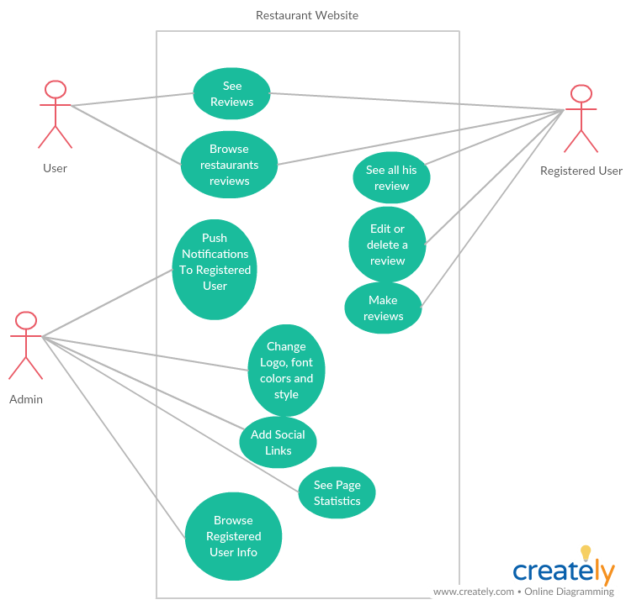

Tools We Used:-

1- Pencil GUI builder for UI design.
2-Github for managing workflow.
3-Visual studio code as IDE.
4- Jquery Library.

What We Implement:-
1-Implement all mock-up design using pure HTML & CSS
2- make Pop-ups screens in authentication & reviews using Jquery.
3- Generate HTML & CSS style by java-script loop to create a large number of reviews.
4- Make the website with fixed size width 800px and height 700px to make sure It will be the same in each different resolution. (Because we didn’t learn bootstrap and how to make the website responsive).

The Web Application will look like that :

1- Hompage
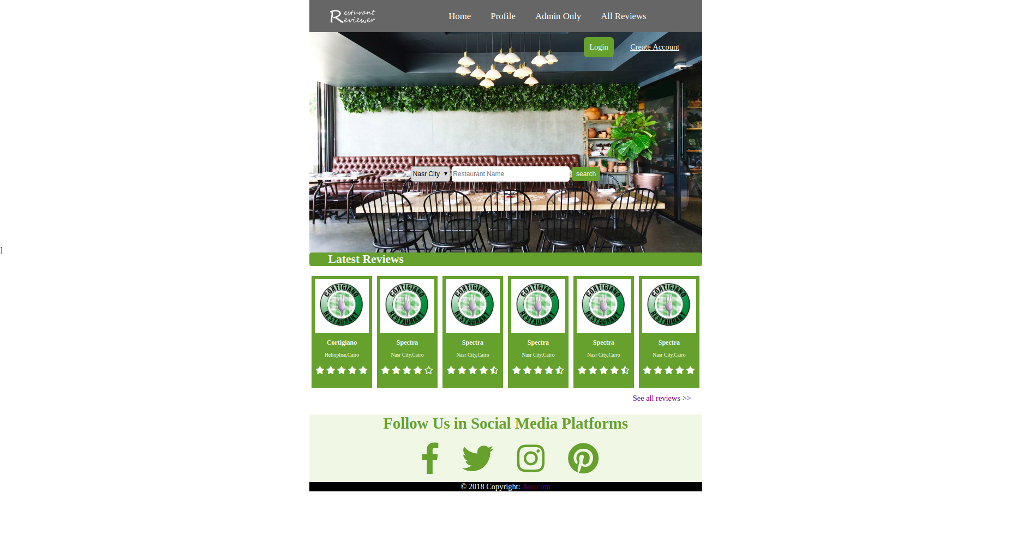

2- Profile Page
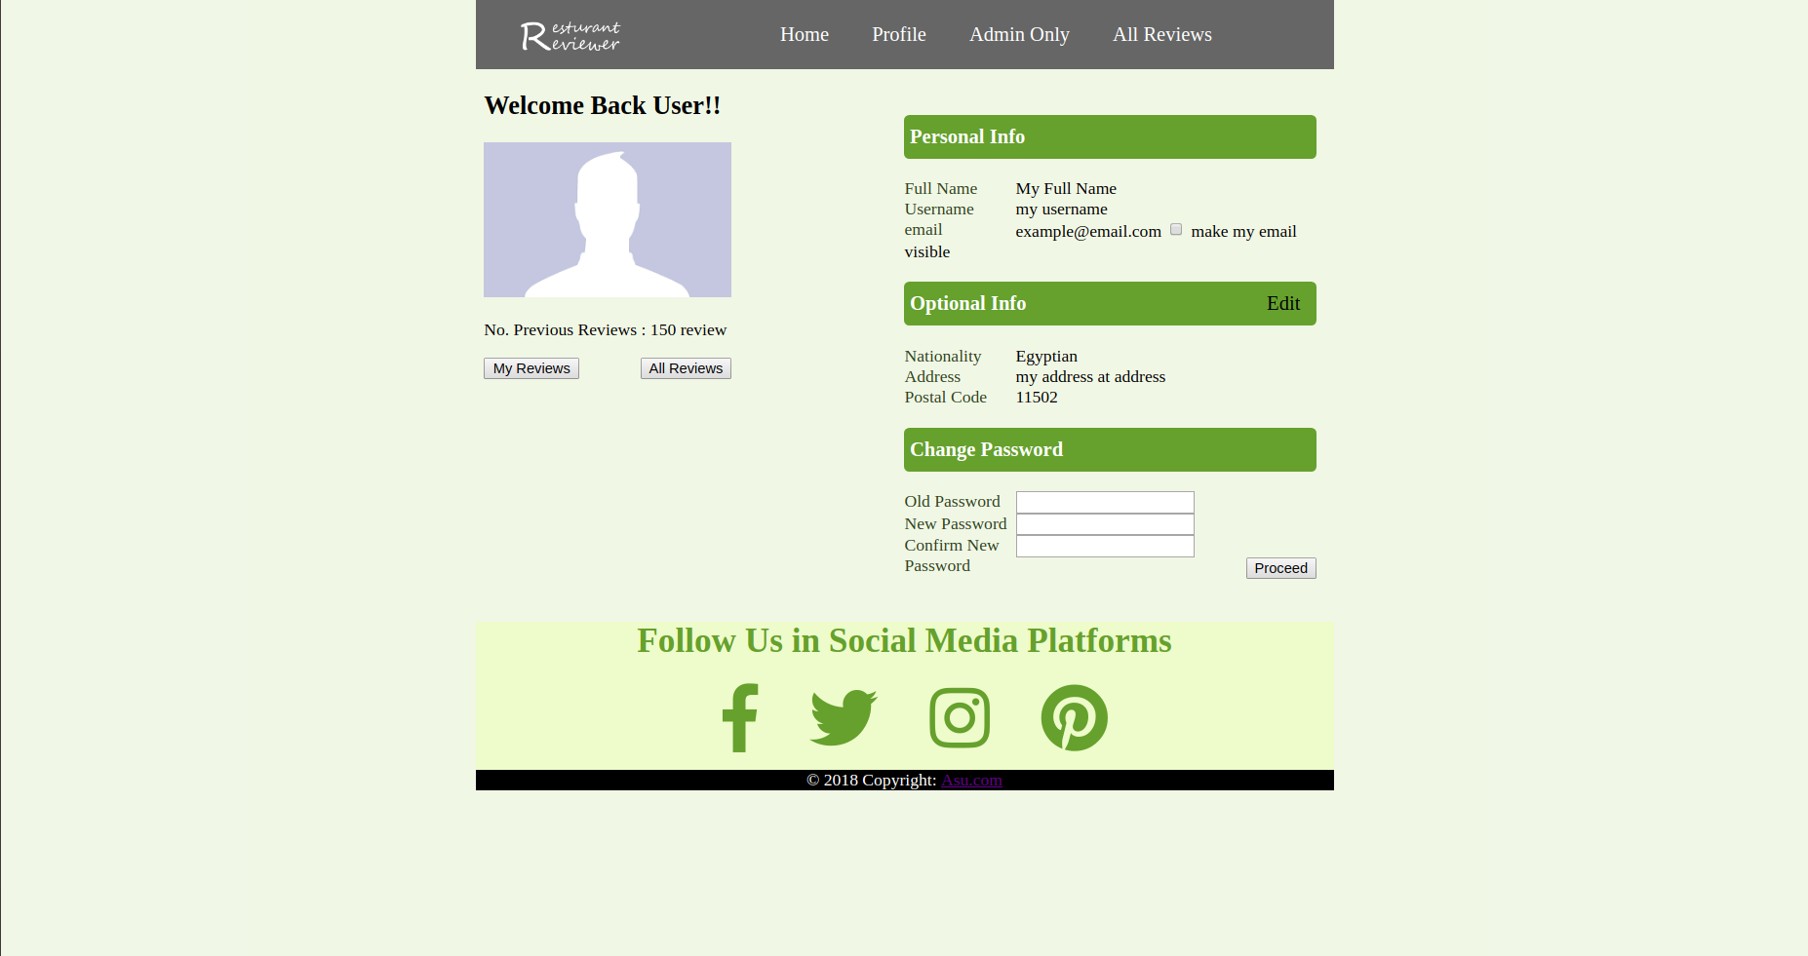

3- Admin Page
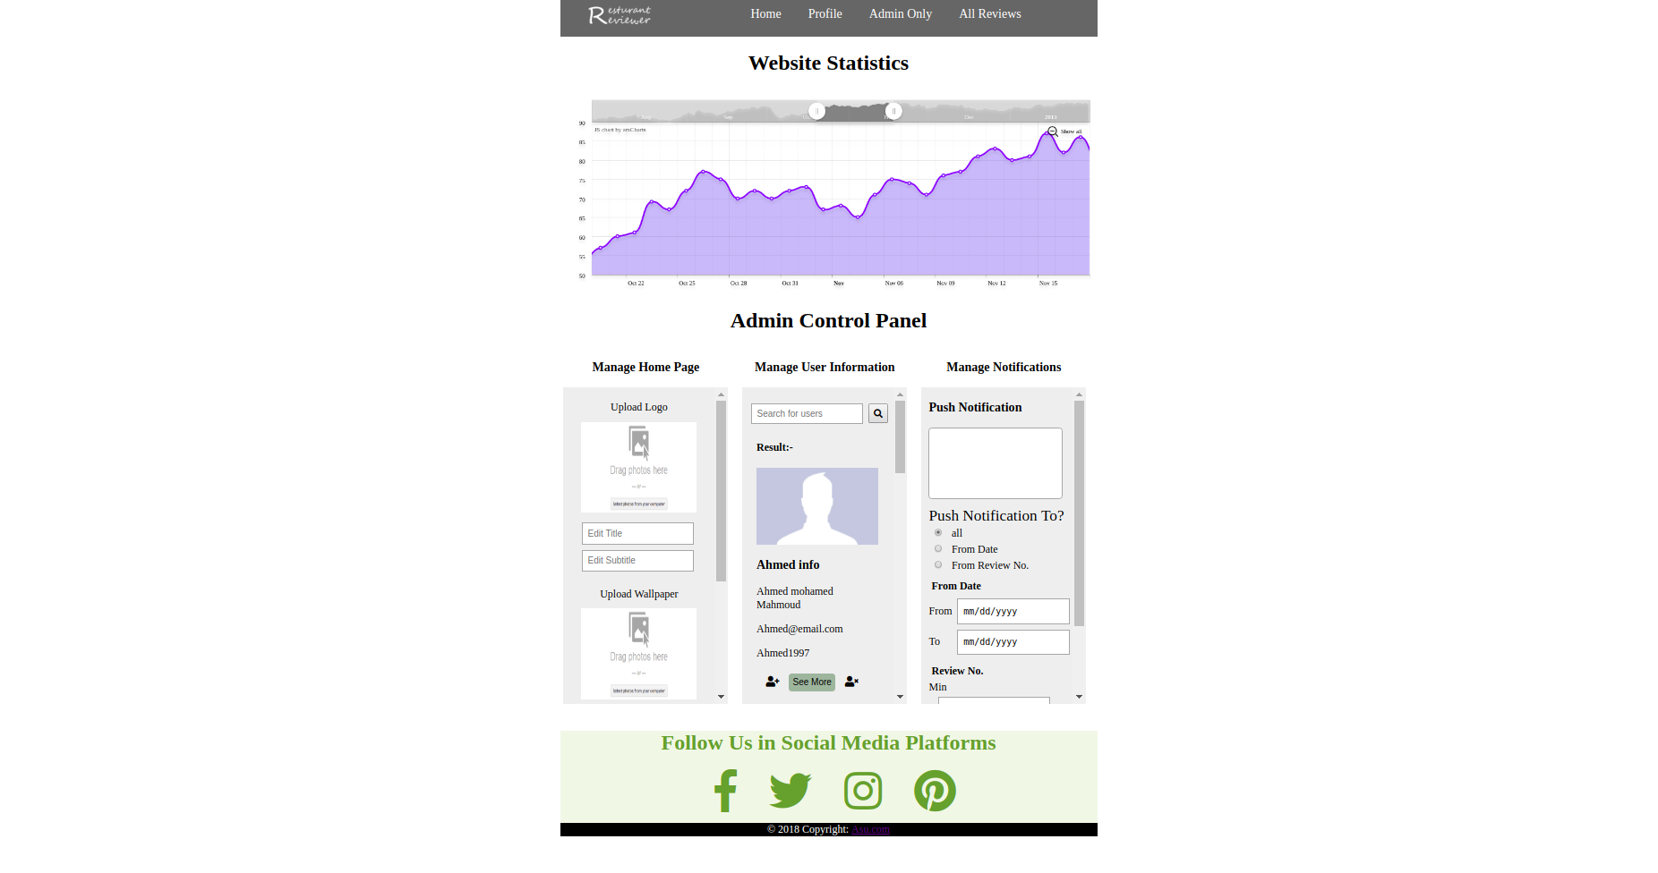

4- Reviews Page

